Course Name: | Digital Signal and Image Processing | Semester: | VI
Date of Performance: | 22 / 03 / 26 | DIV/ Batch No: | A1
Student Name: | Aaryan Sharma | Roll No: | 16010123012

Title: Write a program to apply the global processing technique: Histogram equalization on a digital image

Objective: To learn and understand the concept of histogram stretching and equalization in image enhancement operations.

Expected Outcome of Experiment:

CO | Outcome
CO4 | Design & implement algorithms for digital image enhancement, segmentation & restoration.

Books/ Journals/ Websites referred:
- http://www.mathworks.com/support/
- www.math.mtu.edu/~msgocken/intro/intro.html.

- R. C.Gonsales R.E.Woods, “Digital Image Processing”, Second edition, Pearson Education
- S.Jayaraman, S Esakkirajan, T Veerakumar “Digital Image Processing “Mc Graw Hill.
- S.Sridhar,”Digital Image processing”, oxford university press, 1st edition."
Pre Lab/ Prior Concepts:
Image histogram:
In an image processing context, the histogram of an image normally refers to a histogram of the pixel intensity values. This histogram is a graph showing the number of pixels in an image at each different intensity value found in that image. For an 8-bit greyscale image there are 256 different possible intensities, and so the histogram will graphically display 256 numbers showing the distribution of pixels amongst those greyscale values. Histograms can also be taken of color images either individual histogram of red, green and blue channels can be taken, or a 3-D histogram can be produced, with the three axes representing the red, blue and green channels, and brightness at each point representing the pixel count. The exact output from the operation depends upon the implementation; it may simply be a picture of the required histogram in a suitable image format, or it may be a data file of some sort representing the histogram statistics.
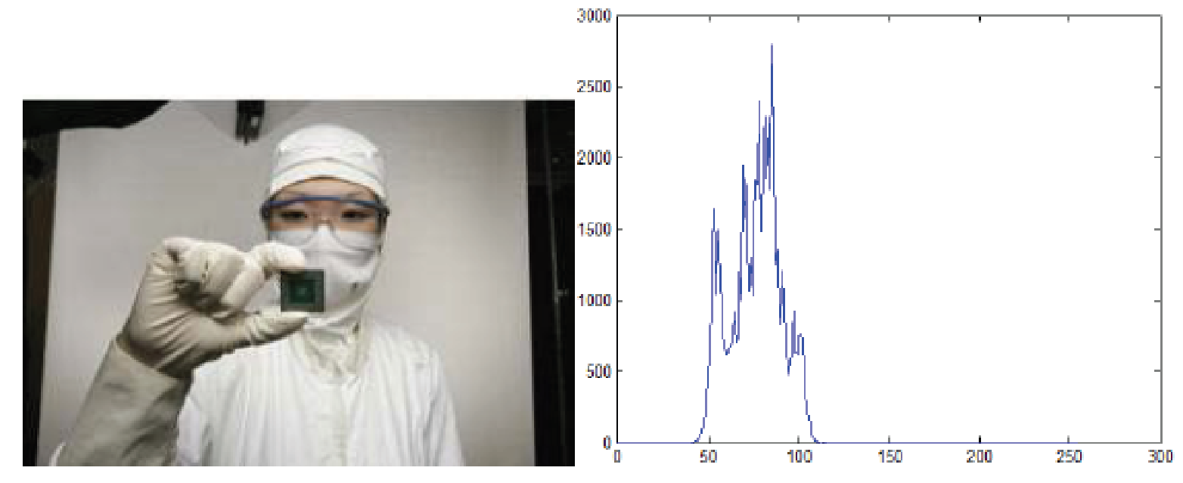
Fig. 1 An image and its histogram
Histogram Equalization:
A perfect image is one which has an equal number of pixels in all its grey levels. Hence our objective is not only to spread the dynamic range , but also to have equal pixels in all the grey levels. This technique is known as histogram equalization. Basically the histogram equalization spreads out intensity values along the total range of values in order to achieve higher contrast. This method is especially useful when an image is represented by close contrast values, such as images in which both the background and foreground are bright at the same time, or else both are dark at the same time. For example, the result of applying histogram equalization to the image in figure 1 is presented in figure 2.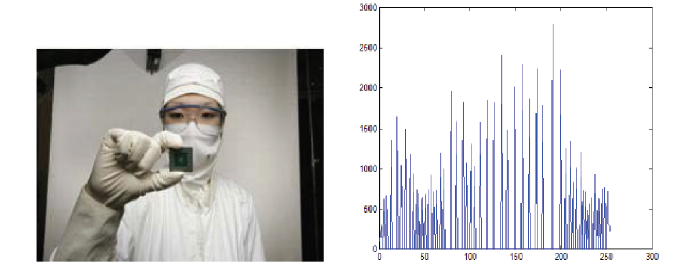

Fig. 2 New image and its equalized histogram
Description of cumulative histogram equalization:
Here are the steps for implementing this algorithm.
1. Create the histogram for the image.
2. Calculate the cumulative distribution function histogram.
3. Calculate the new values through the general histogram equalization formula.
4. Assign new values for each gray value in the image.
Thus processed image is obtained by mapping each pixel with level rk into a corresponding pixel with level sk in o/p image. This transformation is called Histogram equalization
Resources Used: Matlab
Implementation Details:
clc;
clear;
close all;

img = imread('image.jpg');
if size(img,3) == 3
img = rgb2gray(img);
end

figure;
imshow(img);
title('Original Image');

figure;
imhist(img);
title('Original Histogram');

eq_img = histeq(img);
figure;
imshow(eq_img);
title('Equalized Image');

figure;
imhist(eq_img);
title('Equalized Histogram');
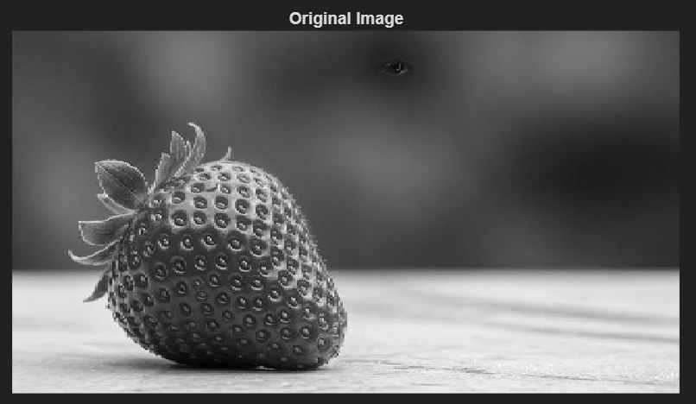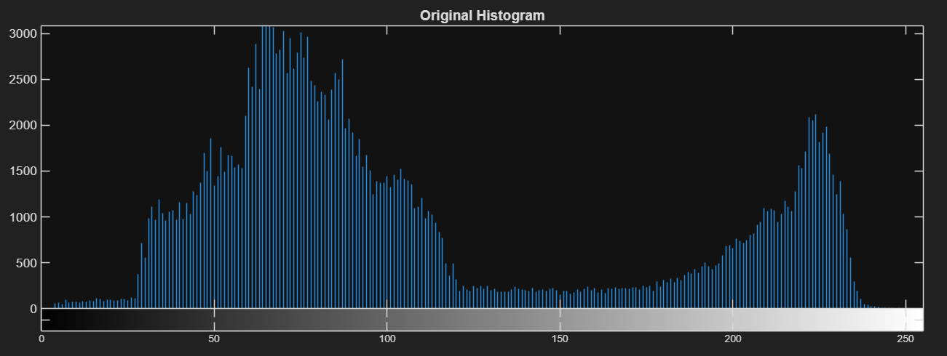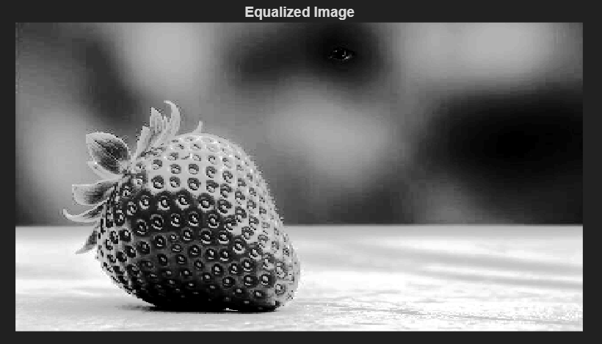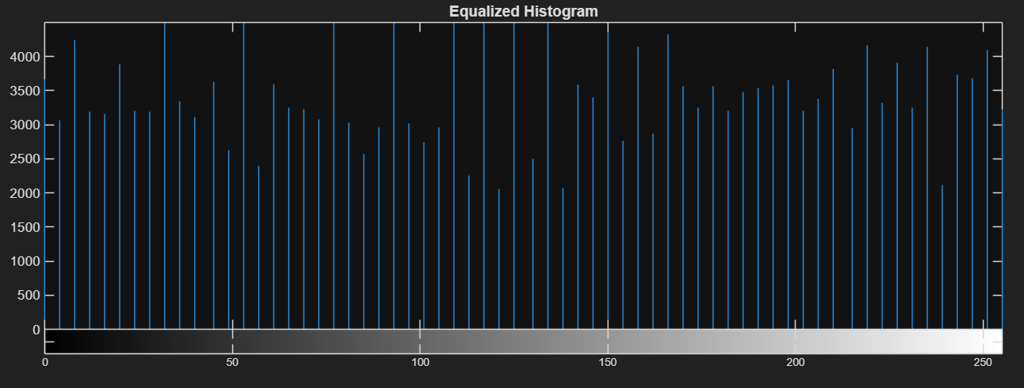
Write Algorithm and Matlab commands used
Algo:
- Start the program.
- Read the input image.
- Check if the image is RGB; if yes, convert it to grayscale.
- Compute the histogram of the grayscale image.
- Calculate the cumulative distribution function (CDF) of the histogram.
- Normalize the CDF values.
- Map the original pixel intensities to new values using the equalization formula.
- Generate the equalized image using the new intensity values.
- Display the original image and its histogram.
- Display the equalized image and its histogram.
Commands:
- imread() – Reads the input image
- rgb2gray() – Converts RGB image to grayscale
- size() – Checks image dimensions
- figure – Opens a new figure window
- imshow() – Displays the image
- title() – Adds title to image/graph
- imhist() – Displays histogram of image
- histeq() – Performs histogram equalization
Conclusion:
In this experiment, I implemented histogram equalization as a global image processing technique using MATLAB. I observed that histogram equalization redistributes pixel intensities to enhance image contrast, especially in low-contrast images. The comparison of original and equalized histograms showed a more uniform distribution of intensity levels.
Date: 22 / 03 / 26 Signature of faculty in-charge
Post Lab Descriptive Questions
Compare between contrast stretching and histogram equalization.
Feature | Contrast Stretching | Histogram Equalization
Type | Linear transformation | Non-linear transformation
Working | Expands intensity range between selected limits | Redistributes intensities using histogram
Control | Controlled using parameters (r₁, r₂, s₁, s₂) | Automatic process
Output | Improves contrast moderately | Improves contrast significantly
Histogram | Stretched but shape remains similar | Becomes more uniform
Use Case | When intensity range is narrow | When image has poor contrast overall

